**Project Report**

Introduction to Ubuntu and Debugging modules of Kernel

Project Member

**Ganesh Zilpe**

**(1207578251)**

Project Supervisor

**Prof. Alan Skousen**

October 14, 2014

Ira A. Fulton Schools of Engineering

Arizona State University

ABSTRACT

Advanced operating system course deals with multiple concepts of operating system: Protection and file systems. Communication, processes, synchronization, naming, fault tolerance, security, data replication, and coherence in distributed systems, real-time systems. Practical approach is very important to understand above mentioned concept. Therefore, studying and experimenting with operating system source code is important to do that.

Ubuntu is open source operating system. As it is open source, we can test its source code to understand how the concepts actually are programmed and how they are functioning. This project deals with installation of Ubuntu on VMware player and then debugging loaded module of kernel.

CONTENTS

INTRODUCTION 4

Chapter 1: Installation of Ubuntu 5

About Ubuntu: 5

About VMware Player: 5

Installation of VMware Player: 5

Installation of Ubuntu 6

Chapter 2: Download and compile the Linux Kernel 9

Step 1: Make a directory for kernel development. 9

Step 2: Download and Install utilities 9

Step 3: Download and Decompress source code of OS 11

Step 4: Compile the downloaded source code 12

Step 5: Compare Versions of before loading and after loading compiled code 14

Chapter 3: Build and Debug a .ko and an App 16

Step 1: Compile the following program cse536app.c in your development directory (CSE536) on Ubuntu: 16

Step 2: Patch the kconfig and Makefile files in the driver/char directory and compile a .ko 16

Step 3: Install and use your .ko 19

Step 4: Debug the kernel with ddd 27

Step 5: Dubug your .ko 32

Table of Figures 38

References 39

# INTRODUCTION

The project is done under Advance Operating System course. The idea behind this project to get familiarize with Ubuntu operating system and feel free to experiment with the operating system as the source code available because Ubuntu is open source operating system. This project is also involved with debugging of the module of Kernel.

The project is divided into three parts: first is installation of Ubuntu, second is Kernel preparation and third is debugging of kernel module.

# Chapter 1: Installation of Ubuntu

## About Ubuntu:

According to official ubuntu website “Linux was already established as an enterprise server platform in 2004, but free software was not a part of everyday life for most computer users. That's why Mark Shuttleworth gathered a small team of developers from one of the most established Linux projects – Debian – and set out to create an easy-to-use Linux desktop: Ubuntu. The vision for Ubuntu is part social and part economic: free software, available to everybody on the same terms, and funded through a portfolio of services provided by Canonical.”

**About VMware Player:**

VMware player is virtualization software and it creates the virtual machine. To install operating system on virtual machine gives freedom to test anything with source code and see the result. The corruption or failure of operating system does not interfere the working of host operating system. For the project, I have installed Ubuntu OS in VMware player and also Windows 7 is host operating system, Ubuntu is termed as Guest OS in our system.

**Installation of VMware Player:**

The underlying system supports only 32-bit operating system only. This will not create any problem for VMware player. But, it does restrict the VMware player to install the ubuntu of 32-bit and not 64-bit.

I have installed **VMware Player version: 6.0.3 build-1895310.**

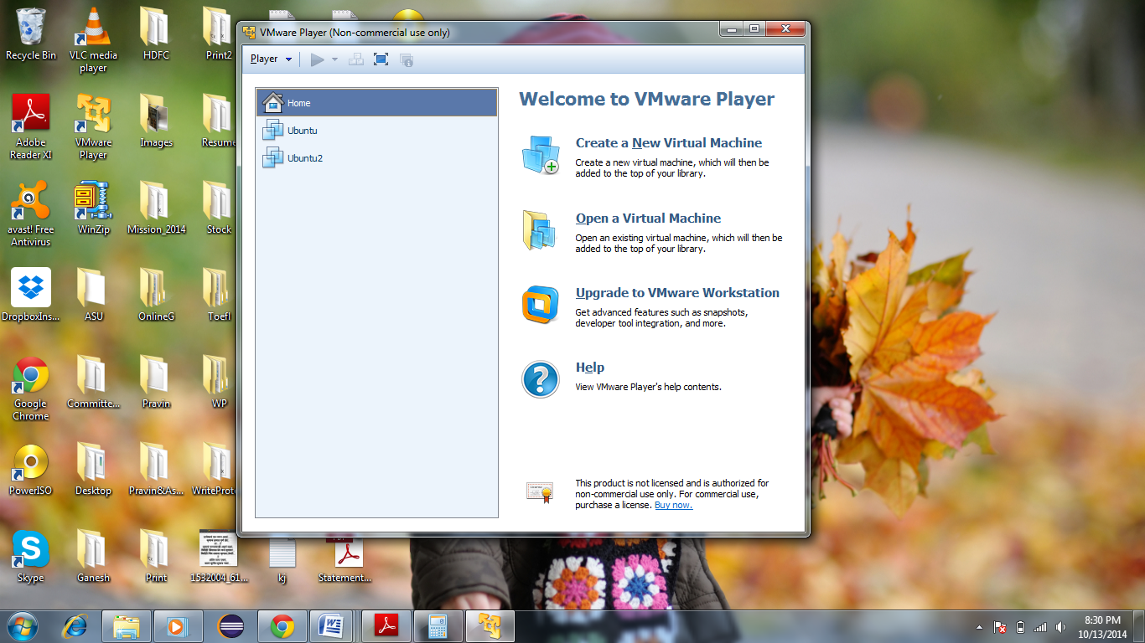

Figure : VMware Player

**Installation of Ubuntu:**

There are numerous version of Ubuntu are available online. But, we might get into trouble while finding update packages of older version. Because I have found out that servers providing upgrade packages are no longer active. Hence, it is advisable to install latest available Ubuntu OS. Currently, in the market Ubuntu 14.04.1 LTS (long-term support) is the latest available version. I have installed the same on VMware Player.

Ubuntu OS: **Ubuntu 14.04.1 LTS**

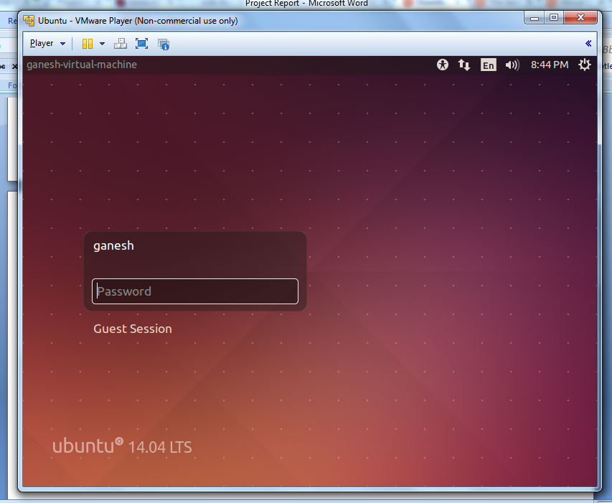

Figure : Ubuntu OS

But, there is one problem when we install Ubuntu 14.04.1 on underlying hardware which supports only 32-bit operating system. After installation of ubuntu on VMware player, when we login to the OS, we get flickered desktop with no visible icon or taskbar. I found out the solution for this problem. When you create virtual machine in VMware player, you can change the virtual machine settings. In the setting, you can see Display setting. Uncheck the checkbox of Accelerate 3D graphics.

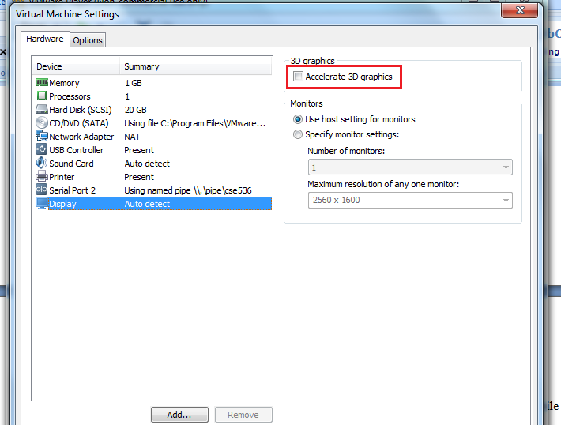

Figure : Solution to flickered screen of Ubuntu

Click on OK button and play the virtual machine. Ubuntu is now ready for usage.

# Chapter 2: Download and compile the Linux Kernel

In preparation for compiling applications and kernel objects to run in the Ubuntu development environment we need to have the kernel source code and associated utilities available on your copy of Ubuntu.

The following is the step by step procedure of doing above mentioned objective. I have provided images for the result of each step. These commands executed in a terminal CLI will download the kernel source code and produce an installation image that will allow you to upgrade to the latest kernel and subsequently make modifications to it.

## Step 1: Make a directory for kernel development.

mkdir cse536

cd cse536

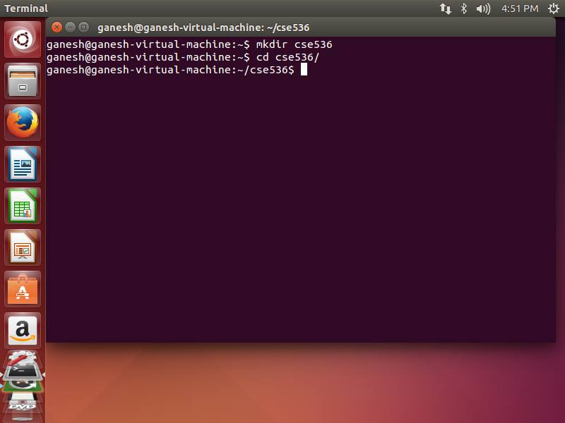

Figure : Create cse536 directory

## Step 2: Download and Install utilities

Download and install the utilities needed to perform the compile and packaging of the kernel. We start by first updating the package list. After that we can download all of the needed packages. Some will have already been installed so this is a shotgun approach but should capture any missing utilities.

sudo apt-get update

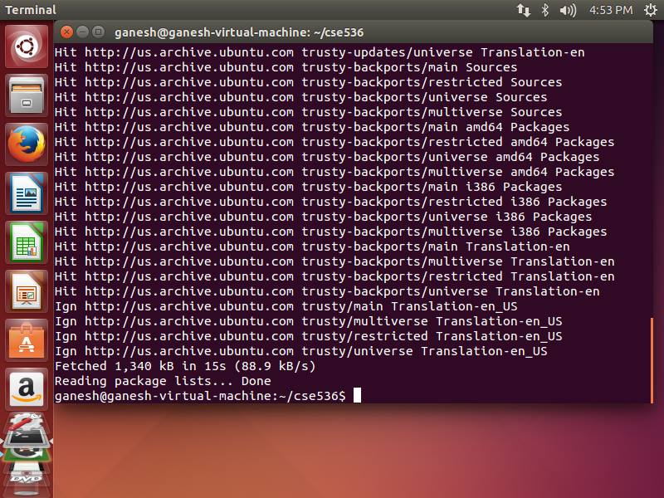

Figure : Update Ubuntu

sudo apt-get install dpkg-dev kernel-package gcc libc6-dev binutils make bin86 module-init-tools gawk gzipgrep libncurses5-dev

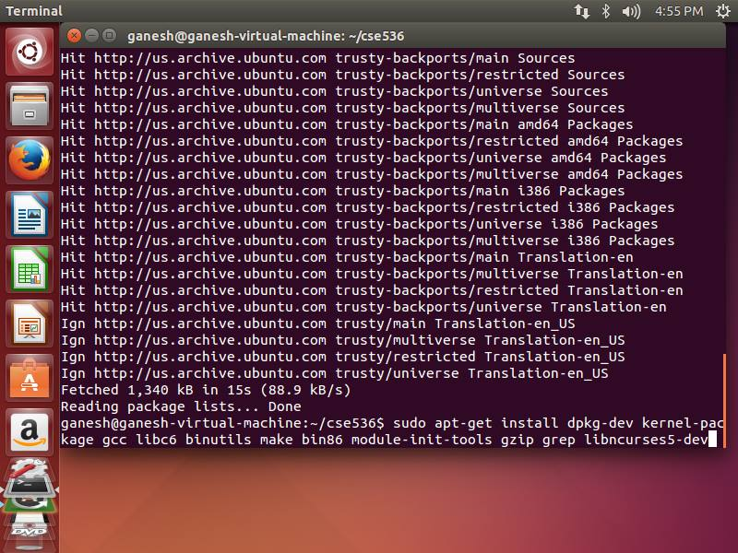

## Step 3: Download and Decompress source code of OS

The next instruction downloads and decompresses the source code for the latest kernel from the Ubuntu source tree. Do not use root for this.

apt-get source linux-image-$(uname -r)

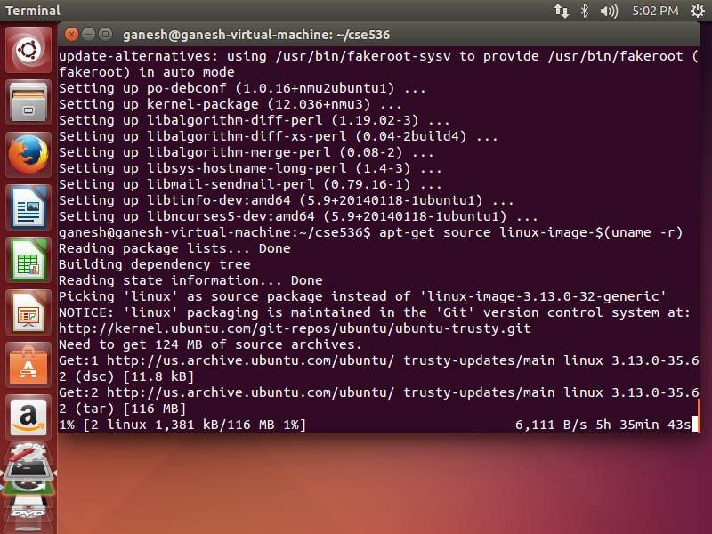

Figure : download ubuntu

## Step 4: Compile the downloaded source code

This step will take the longest. We must first

a) Change the working directory to be the top level source directory for the kernel.

b) Configure the kernel. For now we will retain the default configuration so just exit after the configuration starts.

cd linux-3.5.0

make menuconfig

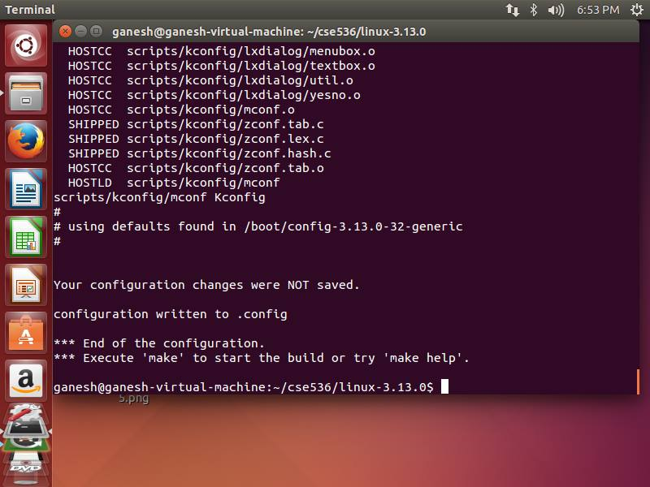

Figure : menuconfig

c) The last preparatory step is to clean the build environment. This will cause everything to be rebuilt.

make-kpkg clean

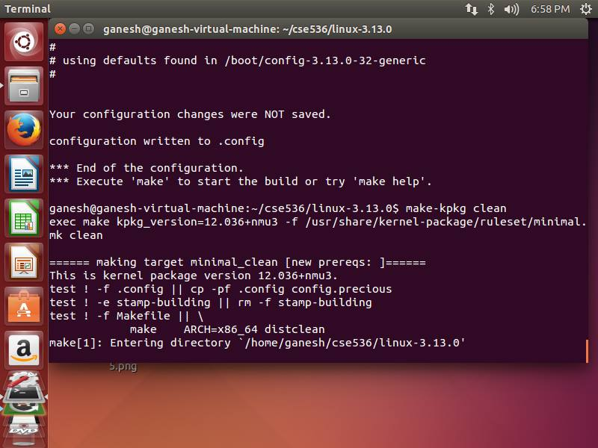

Figure : clean build environment

d) The last command will take several hours to complete so be sure your computer is plugged in and is not set to sleep. For some computers it may take all night. Do not use any root privileges in this step.

fakeroot make-kpkg --initrd --revision=1.0.cse536 kernel_image

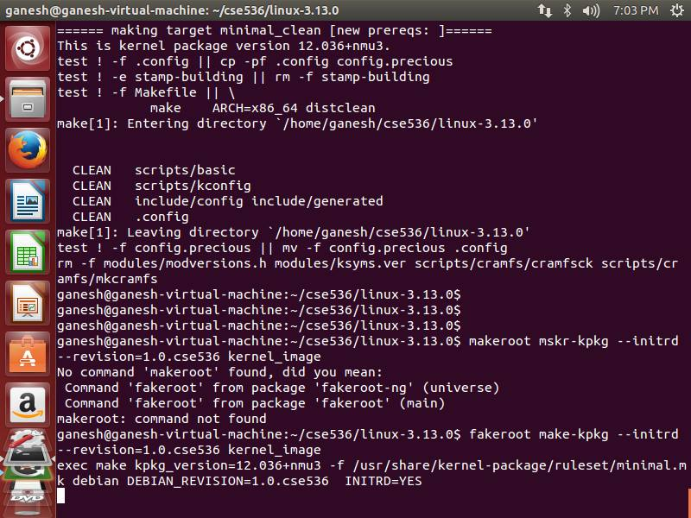

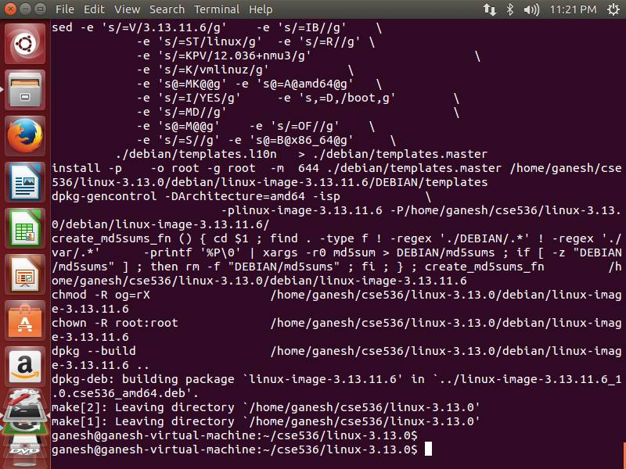

## Step 5: Compare Versions of before loading and after loading compiled code

This step will show you your current revision of the OS (Note: *Software Updater* also updated the kernel) and then update the kernel to match your source code. You must reboot (shutdown command) to use the new kernel. You can verify the update by displaying the version again.

cat /proc/version

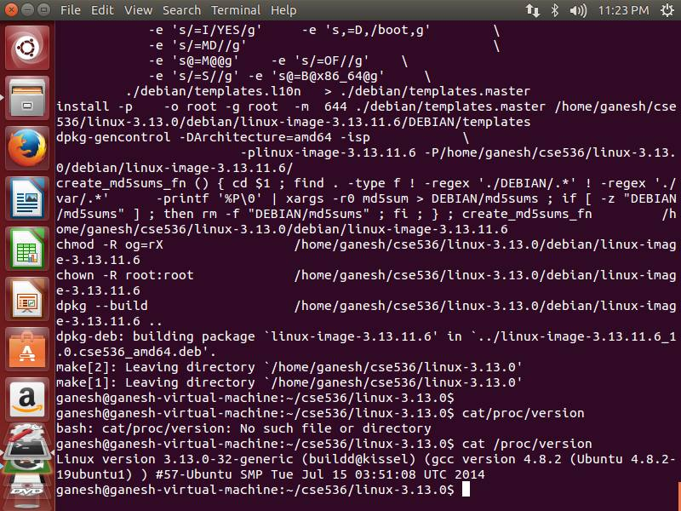

Figure : version before loading new source

sudodpkg -i ../linux-image-3.5.7.2_1.0.cse536_i386.deb

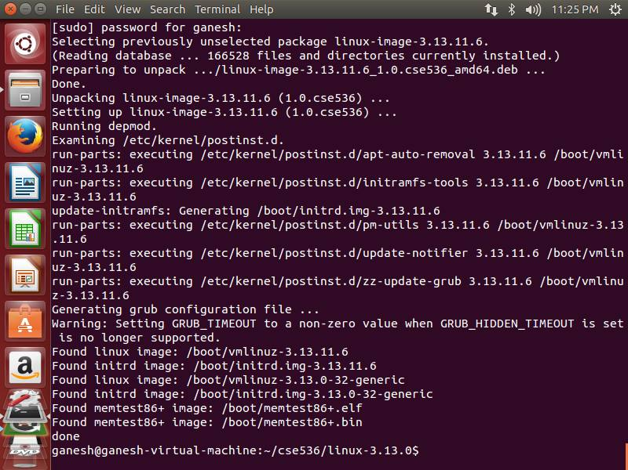

Figure : load new linux image

sudo shutdown -r now

cat /proc/version

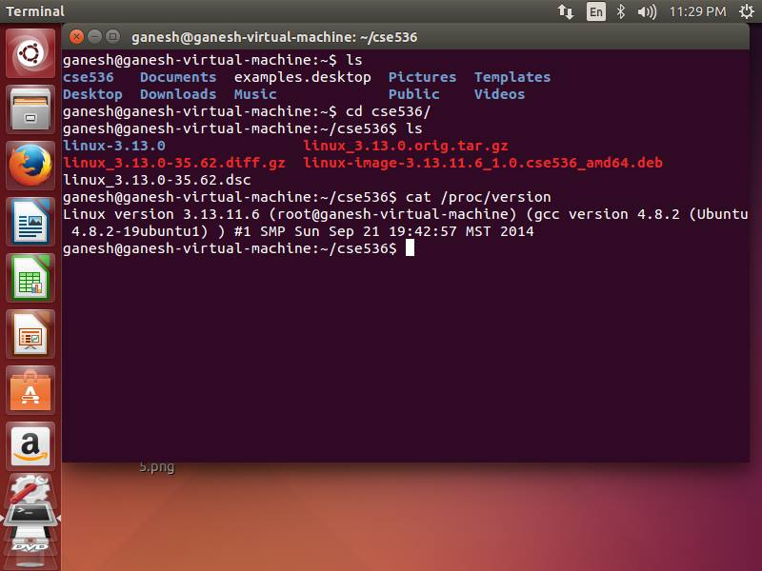

Figure : version after loading new linux image

Now, we have the source code of kernel along with all recently distributed packages.

# Chapter 3: Build and Debug a .ko and an App

In this part of project, our goal is to round out our skill set by building and installing a simple .ko and an application program that accesses the .ko as a device driver. We will be using the simplest of the driver types, a character I/O driver.

## Step 1: Compile the following program cse536app.c in your development directory (CSE536) on Ubuntu:

1. Create cse536app.c and compile and execute the file

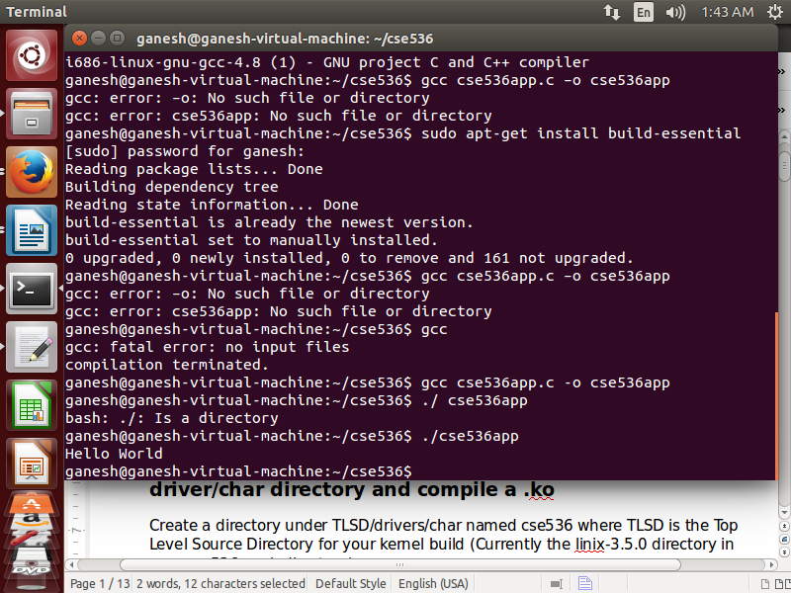

Figure : compile and execute cse536app

## Step 2: Patch the kconfig and Makefile files in the driver/char directory and compile a .ko

1. Create a directory under TLSD/drivers/char named cse536 where TLSD is the Top Level Source Directory for your kernel build (Currently the linix-3.5.0 directory in your cse536 work directory).
2. Copy the following program into a file named cse5361.c in the TLSD/drivers/char/cse536 directory
3. Create a file named Makefile is your TLSD/driver/char/cse536 directory as well. It should contain the line:

obj-$(CONFIG_CSE536) += cse5361.o

1. Paste the following code into TLSD/drivers/char/kconfig. It should be placed at line 7 pushing line 7 (currently: source "drivers/tty/Kconfig") down. Be sure to include the empty line at the end of the paste.

config CSE536

tristate "Enable cse536"

default M

---help---

Enable compilation option for Course CSE536

driver cse536

1. Paste the following code into TLSD/drivers/char/Makefile. It should be placed on line 56 pushing the empty line down:

obj-$(CONFIG_CSE536) += cse536/

We now have a linkage between our .ko source code and the top level Makefile as well as the top level kconfig file.

1. Change your working directory back to the TLSD and restart the menuconfig:

make menuconfig

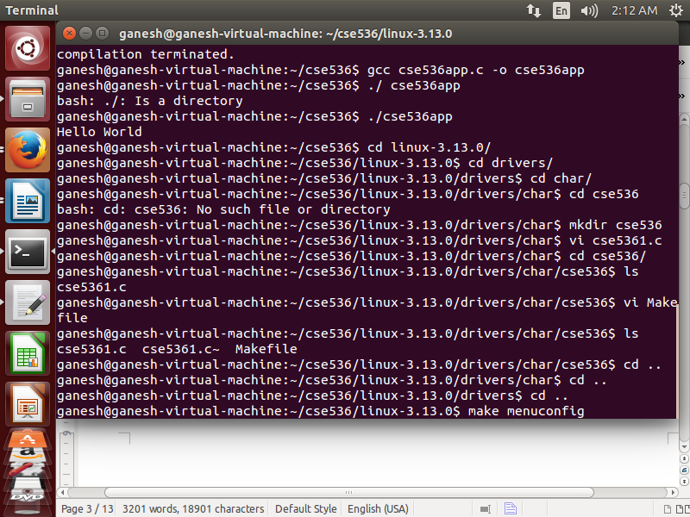

Figure : menuconfig

1. Locate Device Drivers in the menu and hit return

Locate Character Devices and hit return

The first entry should be your new cse536 module, type M.

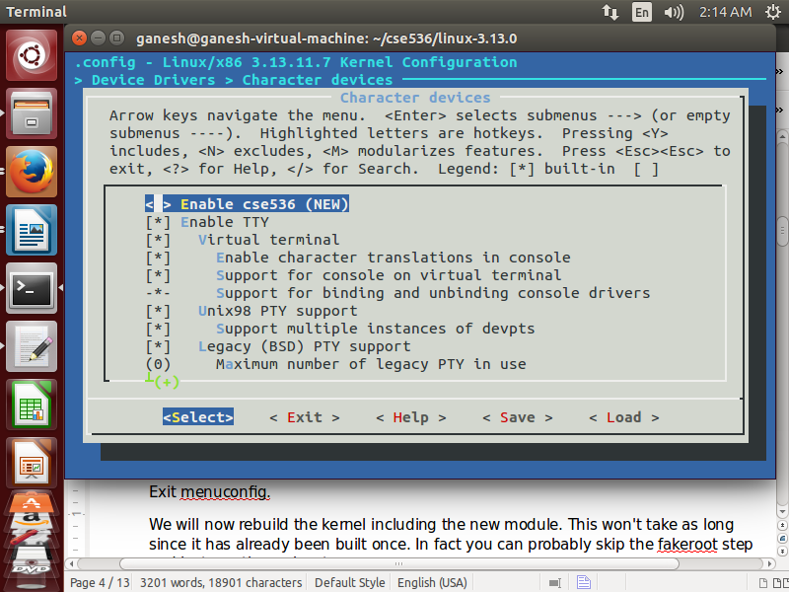

Exit menuconfig

1. We will now rebuild the kernel including the new module. This won't take as long since it has already been built once. In fact you can probably skip the fakeroot step and just use the make step:

fakeroot make-kpkg --initrd --revision=1.0.cse536 kernel_image

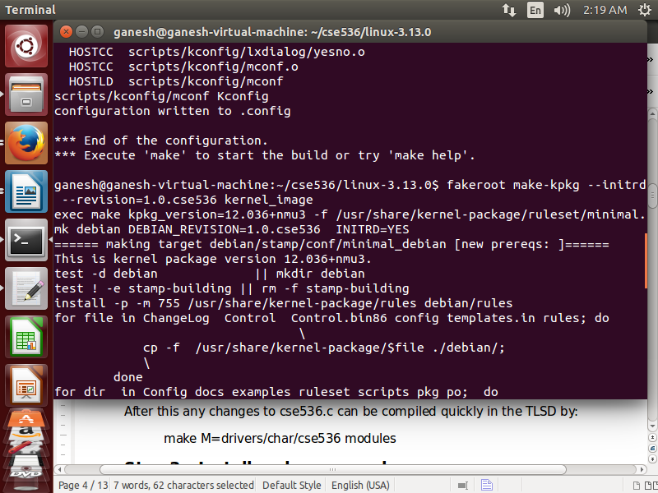

Figure : rebuild kernel using new module

1. After this any changes to cse536.c can be compiled quickly in the TLSD by:

make M=drivers/char/cse536 modules

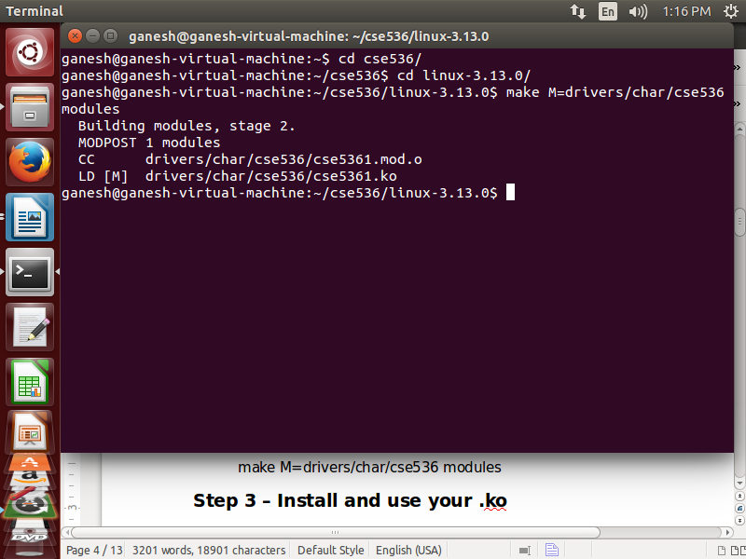

## Step 3: Install and use your .ko

1. If you want to see the output from you .ko module printk function you can use:

dmesg | grep cse536

after the fact or you can see it as it happens by starting xconsole from the CLI and lock it to the launcher for future use:

xconsole&

Alternatively you can start a background display of the prink output using the following command:

tailf /var/log/syslog |grep -i cse536&

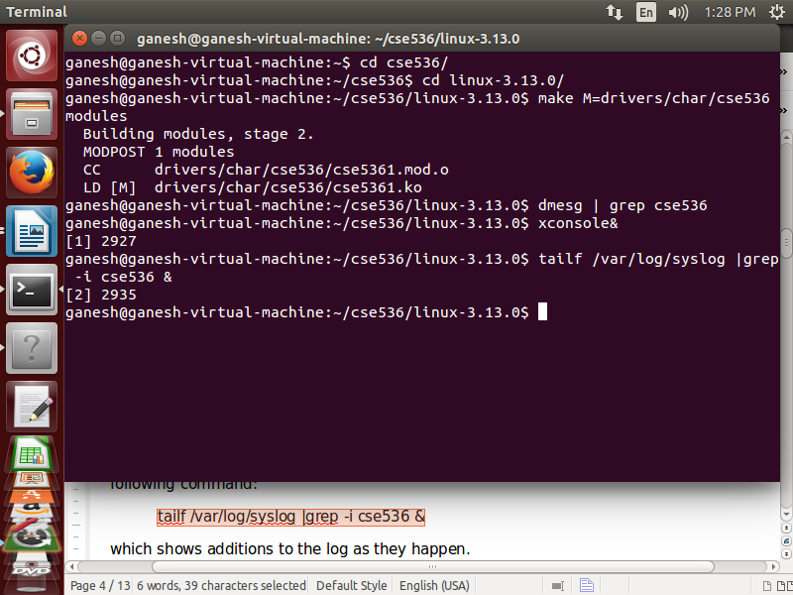

1. To install your .ko on your local system enter the following commands:

This first command creates a device to allow your programs to read and write through the driver:

sudo mknod /dev/cse5361 c 234 0

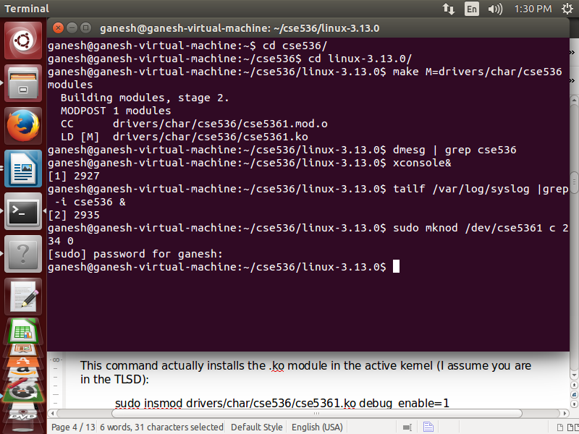

Figure : mknod cse5361

1. This command actually installs the .ko module in the active kernel (I assume you are in the TLSD):

sudo insmod drivers/char/cse536/cse5361.ko debug_enable=1

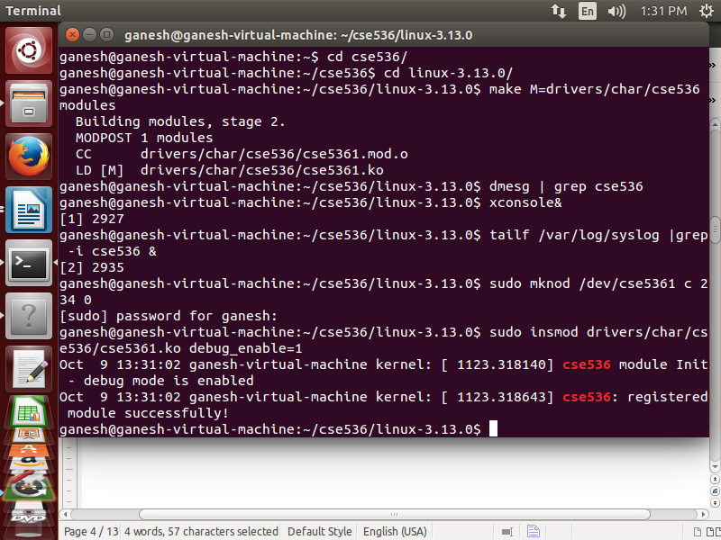

Figure : insert new module in kernel

This command lists the currently loaded modules so you can verify that the module is correctly loaded:

lsmod

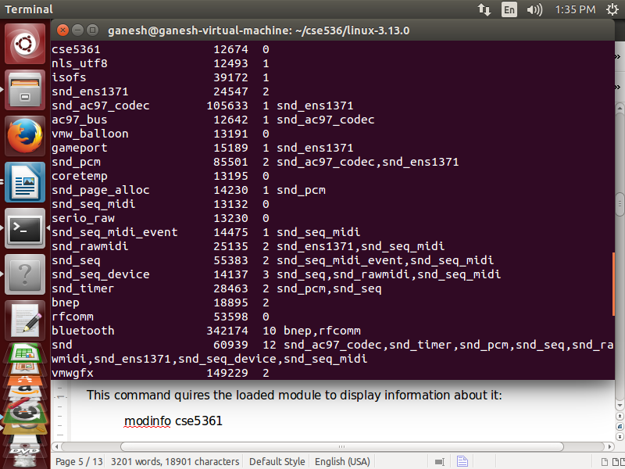

1. This command quires the loaded module to display information about it:

modinfo cse5361

This command displays the output from the printk statements in the module from the system log:

dmesg | grep cse536

This command removes the module so you can change it and reload it if necessary:

sudo rmmod cse5361

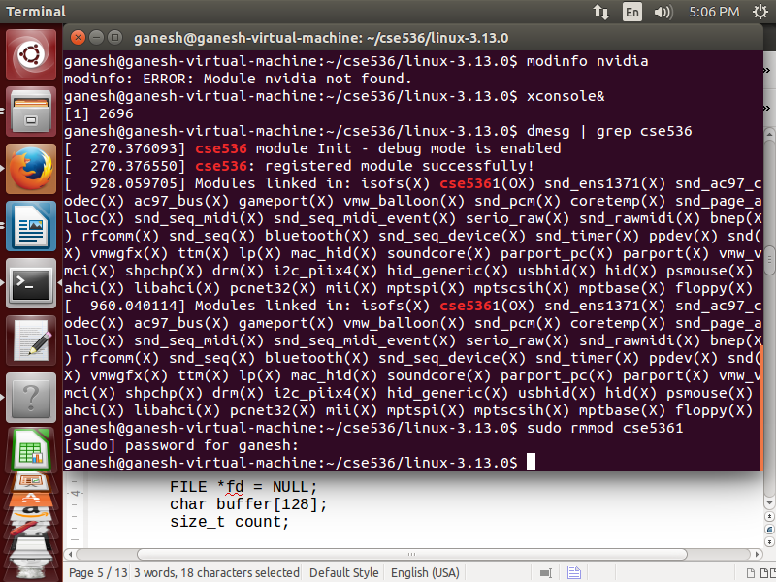

1. Now modify your cse536app program by replacing the printf statement with:

BEGIN COPY AFTER THIS LINE

FILE *fd = NULL;

char buffer[128];

size_t count;

fd = fopen("/dev/cse5361", "rwb");

if (!fd)

{ printf("File error opening file\n");

exit(1);

}

count = fread(buffer, 1, sizeof(buffer), fd);

if (!count)

printf("No data read\n");

else

printf("%s\n", buffer);

fwrite(buffer, 1, 10, fd);

fclose(fd);

END COPY BEFORE THIS LINE

Compile the program with debugging symbols and run it:

gcc cse536app.c –o cse536app –g

./cse536app

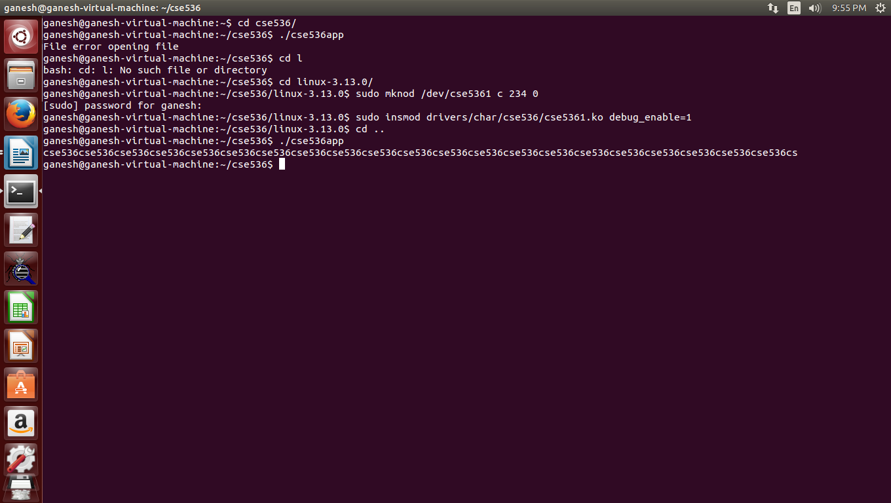

1. sudo apt-get install ddd

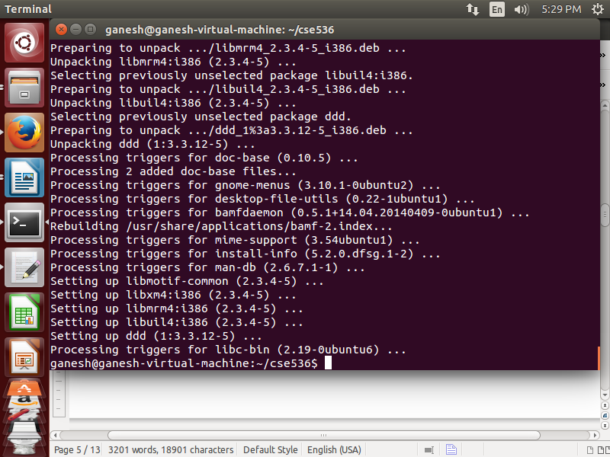

Figure : install ddd

1. Now run the program in the debugger. ddd is the GUI for gdb (you can always just use gdb instead of ddd):

ddd ./cse536app

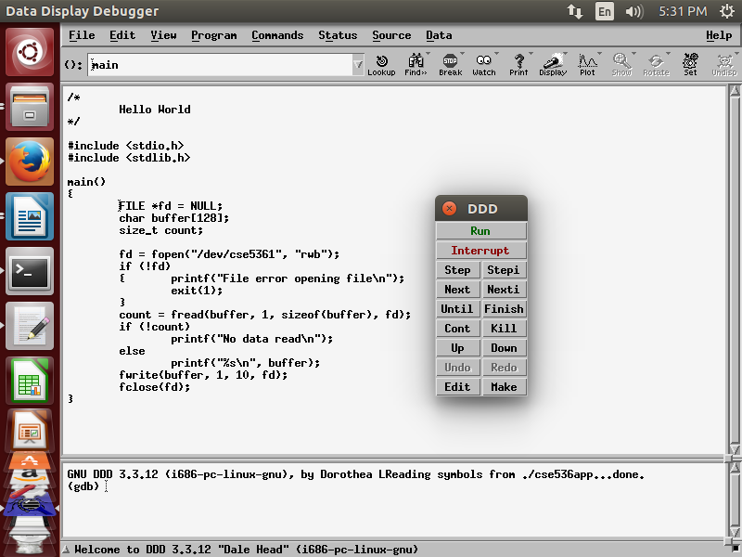

Figure : run program in ddd

1. Place the cursor in front of the fread line of code and click the stop sign to set a breakpoint (assuming you are using ddd).

Click the run button and the program will stop at the break point.

Click on the count variable on line 19 and then click the display button. It will show you the value of count.

Click the step button and watch the value of count change.

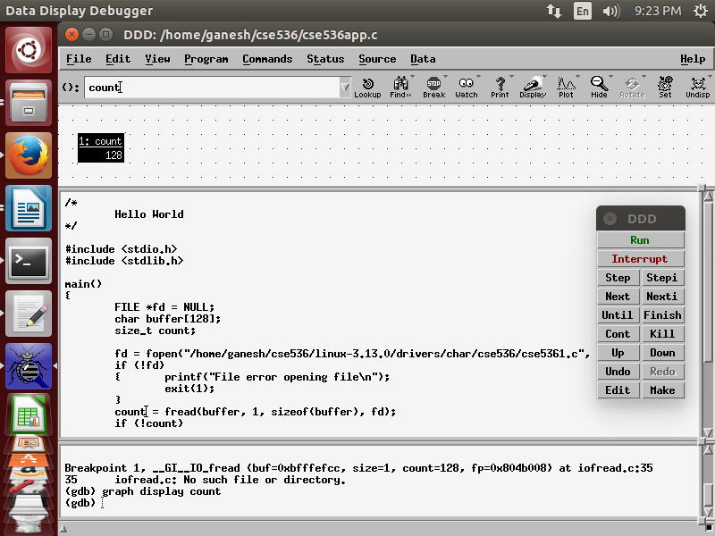

1. Now alter the .ko to actually return some data on a read. Replace the contents of cse536_read in your .ko with:

BEGIN COPY AFTER THIS LINE

ssize_t retCount;

retCount = sprintf(buf, "cse536");

printk("cse536_read: returning %d bytes\n", retCount);

return retCount;

Now recompile your .ko (be sure you are in the TLSD):

make M=drivers/char/cse536 modules

Remove the old module

sudo rmmod cse5361

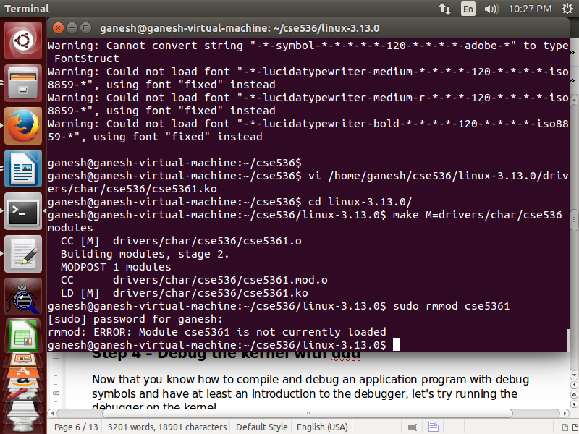

1. Reinstall the module with the changes and run your program again.

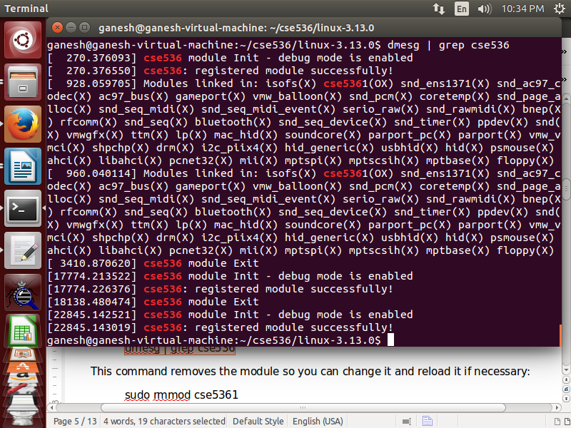

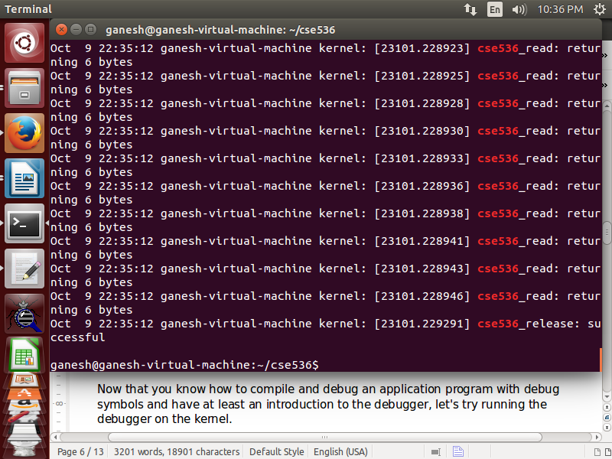

We set the buffer of 128 bytes and it is full with cse536 string: 21 times cse536 and last two bytes are cs.

When I executed the program, I got several times same cse_read: returning (the size of cse536 which is 6) 6 bytes.

## Step 4: Debug the kernel with ddd

1. Once the target VM is up and running there are a number of mechanisms that can be used to transfer files between the VMs. Installing an ssh server on the target VM and using filezilla will work. On your debug VM install filezilla:

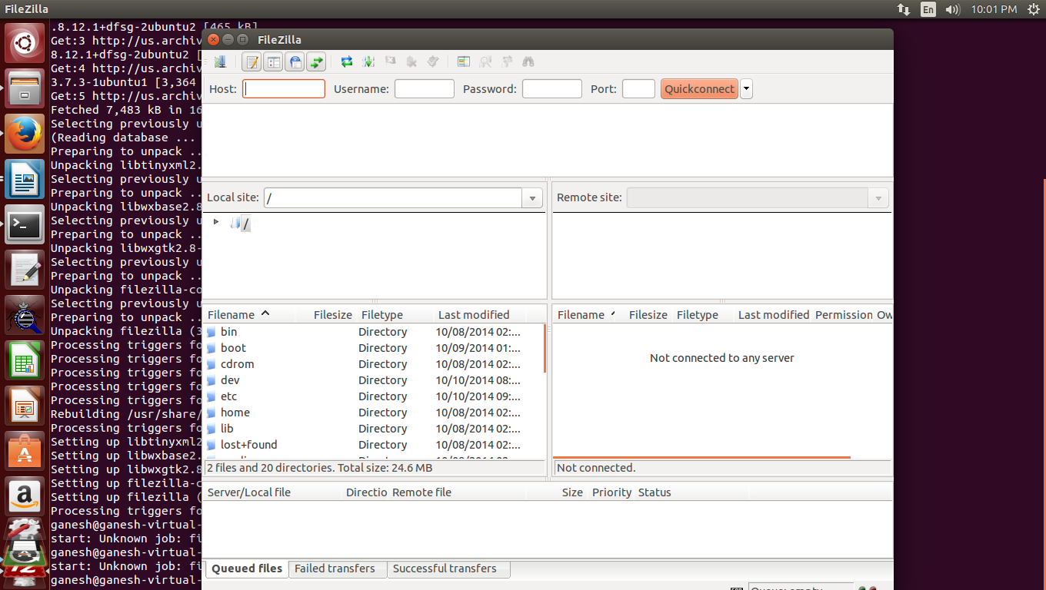

1. Install an ssh server on your target VM:

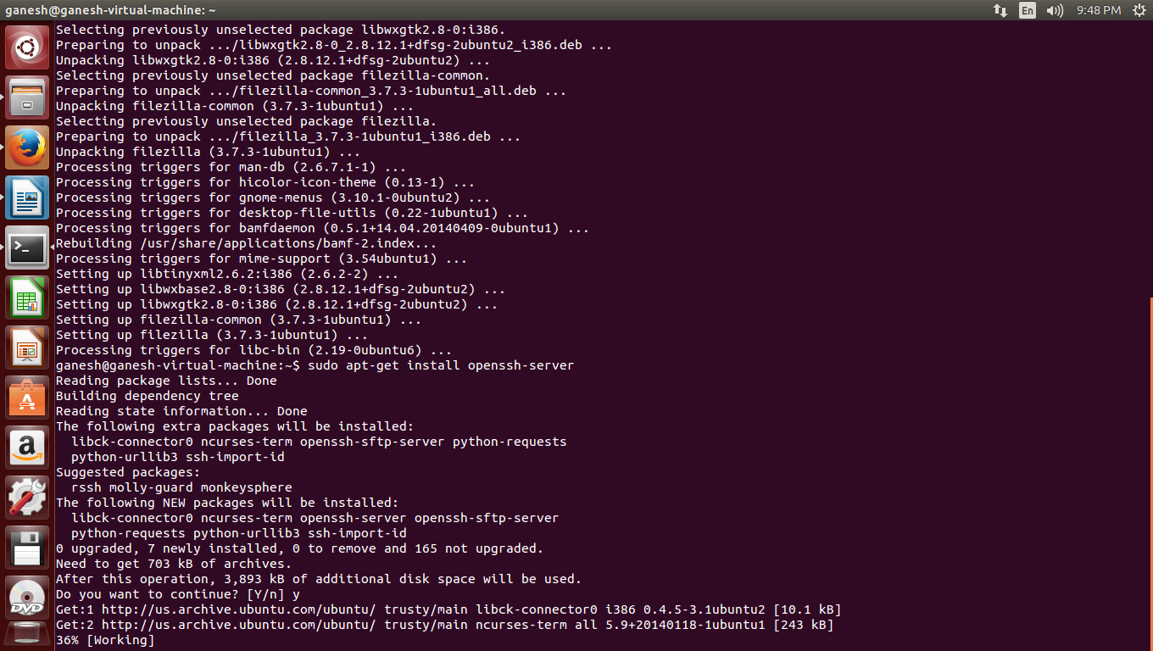

1. Now you can start filezilla on your debug host VM and transfer the .deb install file, .ko module and application programs as needed. You will need to look up the ip number of your target VM or set it statically. You can use:

Target: ifconfig

to discover the ip number. Use port 22 in filezilla where it asks for a port number.

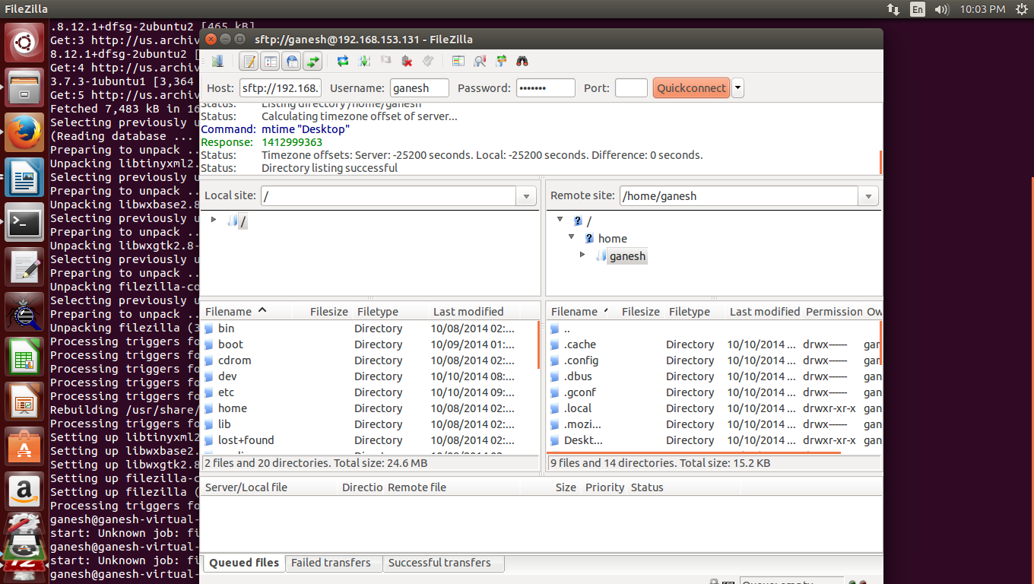

1. Install the compiled kernel from the debug VM onto the target VM:

Target: sudo dpkg -i linux-image-3.5.7.2_1.0.cse536_i386.deb

Reboot the target VM and verify the correct installation using:

Target: cat /proc/version

Install the compiled kernel from the debug VM onto the target VM:

Target: sudo dpkg -i linux-image-3.5.7.2_1.0.cse536_i386.deb

Reboot the target VM and verify the correct installation using:

Target: cat /proc/version

Now let's try debugging a remote program before we take on the kernel. Download gdbserver to the target VM:

Target: sudo apt-get install gdbserver

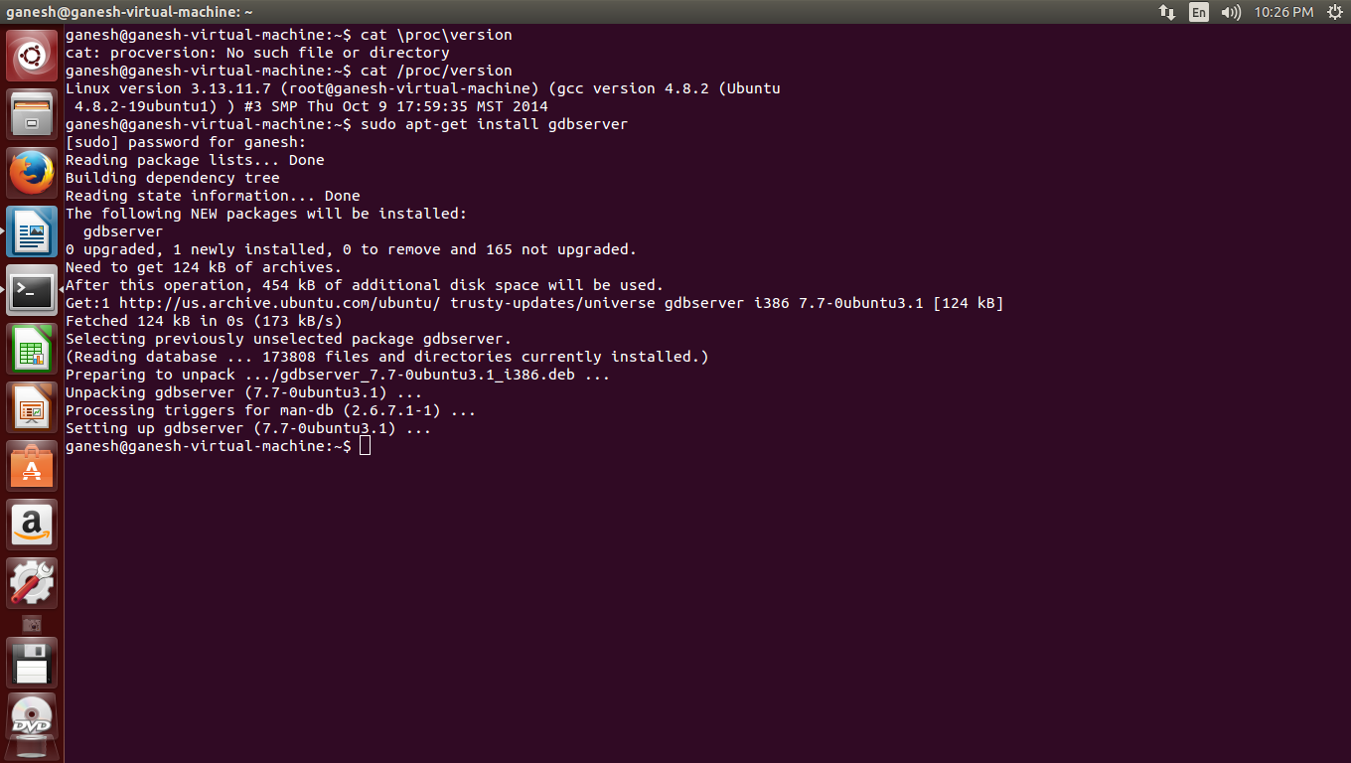

Figure : Installation of gdbserver

Install the .ko on the target VM and run cse536app on the target VM to make sure all is in order.

Next run gdbserver with your app. The reference to host is for a tcp connection at the specified port #:

Target: gdbserver host:5361 ./cse536app

gdbserver will now wait for you to connect from the debug VM. On the debug VM type:

Debug: ddd ./cse536app

Followed by:

Debug: target remote 192.168.153.131:5361

at the gdb prompt at the bottom of the screen. You can now continue as previously instructed when debugging on your local machine but you will notice the program and its output are on the target VM. You can exit ddd by entering q on the gdb command line.

Now let's debug the kernel on the remote VM. To do this you must create a link between the two VMs and prepare the kernel so it can stop itself and connect to the debug VM.

1. To create a link between the two VMs the simplest mechanism is to create a named pipe that both VMs can refer to. On both VMs shut down Ubuntu and open the virtual machine settings (this is for VMware on windows, you will have to research how to do this yourself for VirtualBox or other hypervisors). If a serial port is not already listed in the devices click on add to create a serial port. Select "Use named pipe:". The pipe on both VMs should be named \\.\pipe\cse536. Make the target VM the server end and the debug VM the client. Both ends are virtual machines. Check Yield CPU on poll. Both machines should have connect at power on checked. Restart the machines.

To verify that they are connected we can use minicom. Install minicom on both VMs:

Both: sudo apt-get install minicom

Before you use miinicom add your login account to the dialout group that ttyS… is a member of:

sudo useradd –G dialout cse536

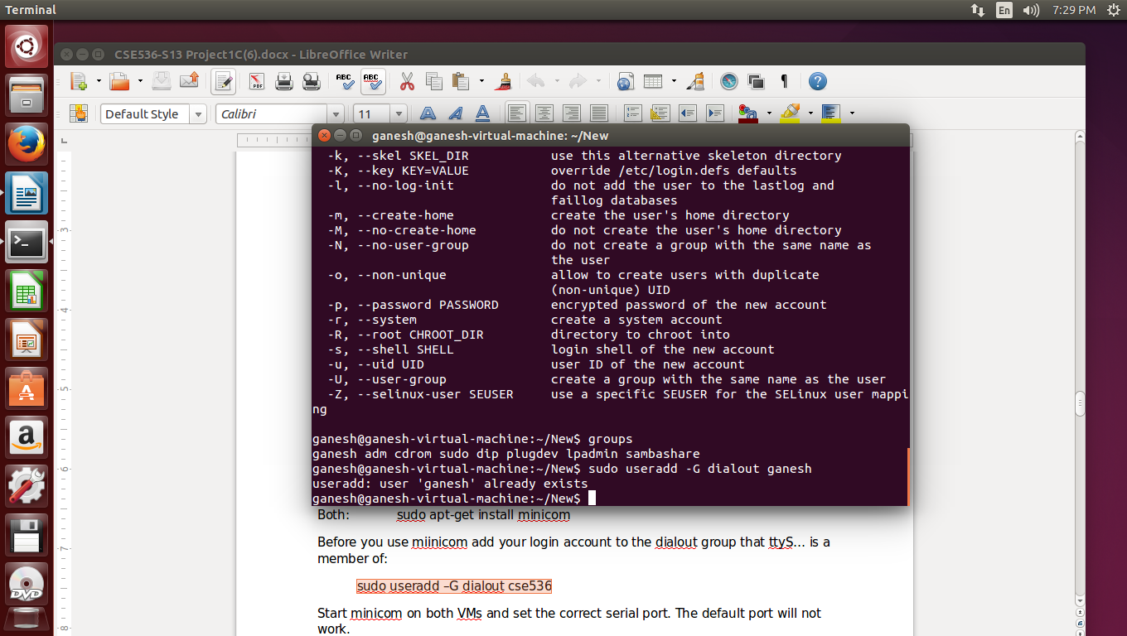

Figure : Add User to dialout group

Start minicom on both VMs and set the correct serial port. The default port will not work.

Both: minicom –s

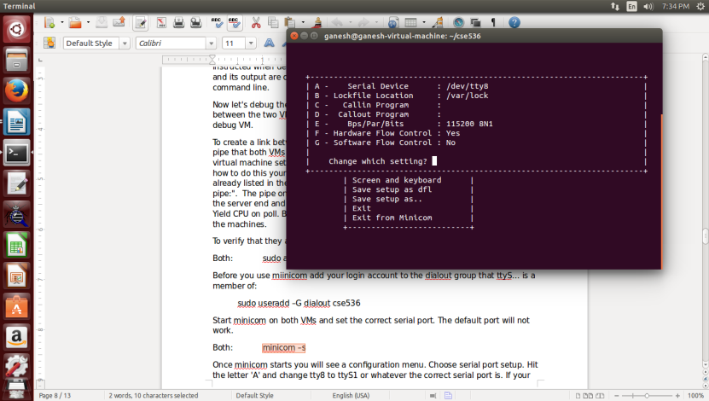

Figure : minicom : Set serial port

Once minicom starts you will see a configuration menu. Choose serial port setup. Hit the letter 'A' and change tty8 to ttyS1 or whatever the correct serial port is. If your VM device list refers to Serial Port 2 when you created the serial port then it is the second serial port or ttyS1. Do this on both VMs then enter twice and choose exit. You should now be connected between the two machines. Whatever you type on one will appear on the other. If this works you are ready to proceed.

You have already compiled the kernel with the debug symbols and kgdb enabled. The next step is to enable debugging from the kernel command line. The kernel command line is a line of parameters passed to the kernel at boot time by the grub loader. Begin by editing a file on the ***target VM***only that manages the kernel command line in the grub loader:

Target: sudo gedit /etc/default/grub&

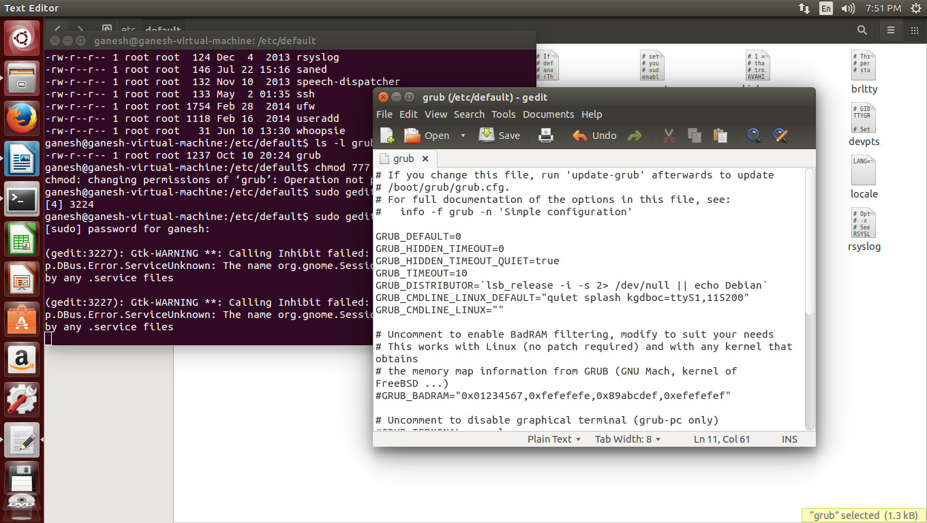

Figure : Edit grub

1. You may then replace the line: GRUB_CMDLINE_LINUX_DEFAULT="quiet splash"

with the line: GRUB_CMDLINE_LINUX_DEFAULT="quiet splash kgdboc=ttyS1,115200"

Assuming ttyS1 is the correct serial port. The next step is to update the grub loader:

Target: sudo update-grub

You should now restart the target VM with the command:

Target: sudo shutdown –r now

When the target VM has restarted enter the command:

Target: dmesg | grep "Kernel command line:"

To verify that the kernel restarted with your new kernel command line. Now enter the

command:

Target: sudo bash

followed by:

Target: echo g > /proc/sysrq-trigger

You will notice that the target VM hangs. It is waiting for you to access it with the debug VM. On the debug VM change your directory to the TLSD and enter the following command:

Debug: ddd vmlinux

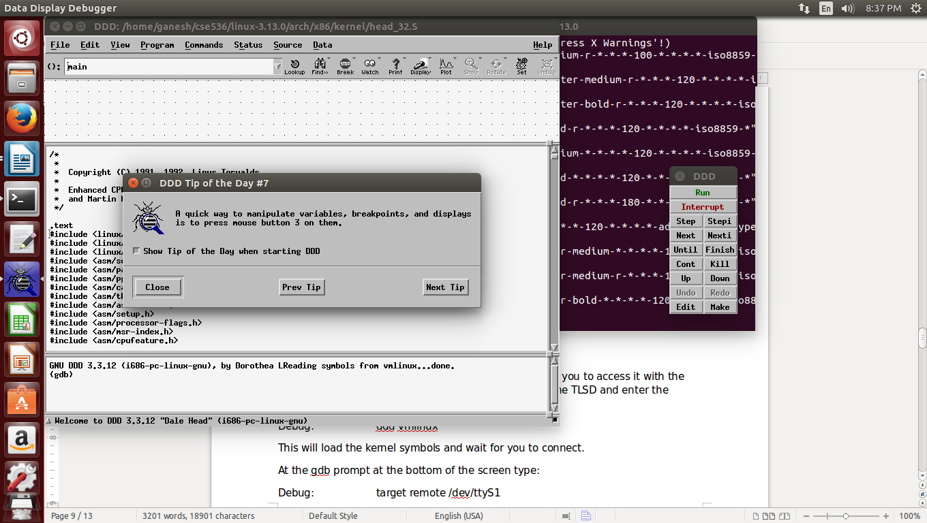

Figure : Start debugger with vmlinux

This will load the kernel symbols and wait for you to connect.

At the gdb prompt at the bottom of the screen type:

Debug: target remote /dev/ttyS1

using the correct serial port if it is not ttyS1. The debug VM and the target VM should now be connected. You can now set a breakpoint on any symbol in the kernel and restart the remote kernel by entering the continue command c at the gdb prompt. To stop the remote kernel any time use the previously described echo g > /proc/sysrq-trigger command in a root bash session as shown before.

## Step 5: Dubug your .ko

The last step in this project is to access your running .ko in the target kernel so you can debug it using ddd. Clearly the simplest debugging tool for a .ko is to use imbedded printk statements and view them on xconsole as they happen on the debug machine (no target machine required).However, as complexity increases and the number of variables we want to display increases the ddd option becomes more attractive. To access the .ko using ddd we have a chicken and egg problem (which came first, the chicken or the egg?). When a .ko is loaded it automatically runs the init function of the module. To debug the init function we need the address of the loaded .ko in order to correctly load the symbols for the .ko but we have to load the .ko and run the init function to get the address to load the symbols. For simplicity we will use printk to debug the init function although there is a way to make it work with ddd by setting a breakpoint in the module loader just before it calls init.

Setting that aside for now, to make the other functions accessible to ddd we create a file that builds a macro in gdb that we can run instead of typing in lots of commands each time we run a debugging session. To begin we need to set up a gdb initfile named csegdbinit in the TLSD that contains the macros:

Debug: gedit csegdbinit

And paste the following code into the csegdbinit file:

BEGIN COPY AFTER THIS LINE

define lsmod

printf "Address\t\t.text\t\tModule\n"

set $m=(struct list_head *)&modules

set $done=0

set $count=$arg0

while ( $count && !$done )

# list_head is 4-bytes into struct module

set $mp=(struct module *)((char *)$m->next - (char *)4)

printf "0x%08X\t0x%08x\t%s\n", $mp, $mp->module_core, $mp->name

if ( $mp->list->next == &modules)

set $done=1

end

set $m=$m->next

set $count = $count - 1

end

if (!$count)

add-symbol-file ./drivers/char/cse536/cse5361.ko $mp->module_core

end

end

document lsmod

List the first n loaded kernel modules and their start addresses and load the symbol table for the nth module

end

define cse536

# file vmlinux

target remote /dev/ttyS1

lsmod $arg0

b cse536_open

c

end

document cse536

load the symbol table at .text address of the nth module and set break at cse536_open

end

END COPY BEFORE THIS LINE

When loaded during ddd or gdb startup it provides two macro functions named cse531 and lsmod. Go ahead and start ddd (or gdb if you don't want a gui interface):

Debug: ddd vmlinux --command csegdbinit



On the target side make sure the mknod and insmod commands have already been run:

Target: sudo mknod /dev/cse5361 c 234 0

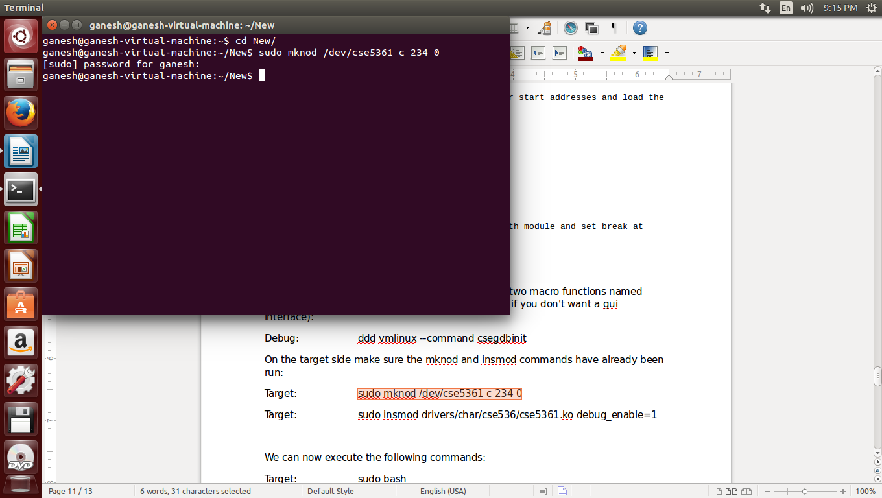

Figure : Create node cse5361 at target VM

Target: sudo insmod drivers/char/cse536/cse5361.ko debug_enable=1

We can now execute the following commands:

Target: sudo bash

to start a root access CLI session on the target machine. We then tell the target kernel to wait for a connection as before:

Target: echo g > /proc/sysrq-trigger

Next we make the connection:

Debug: target remote /dev/ttyS1

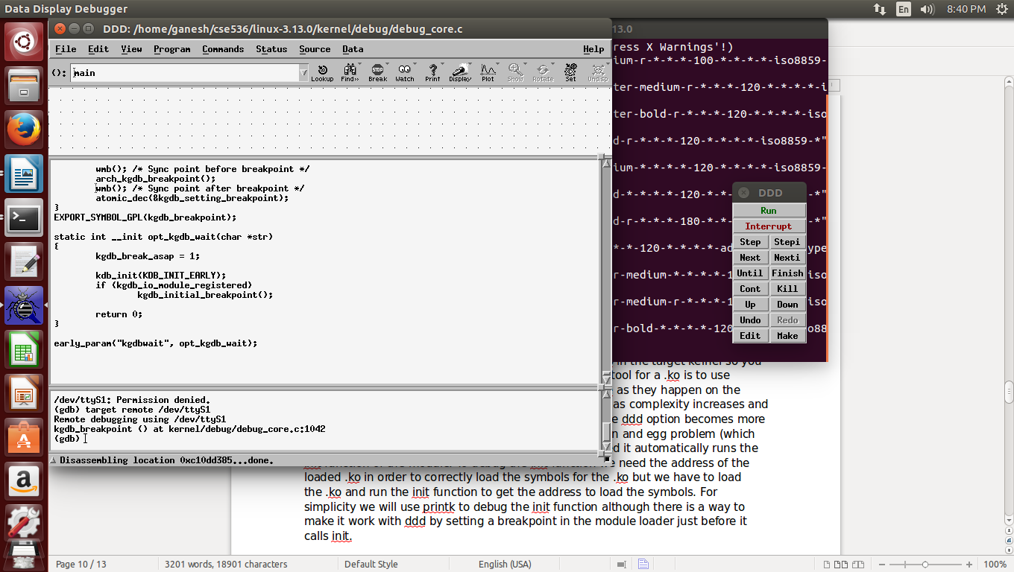

Figure : connect with target through serial port

Now we can run one of the macro functions we created:

Debug: lsmod 1

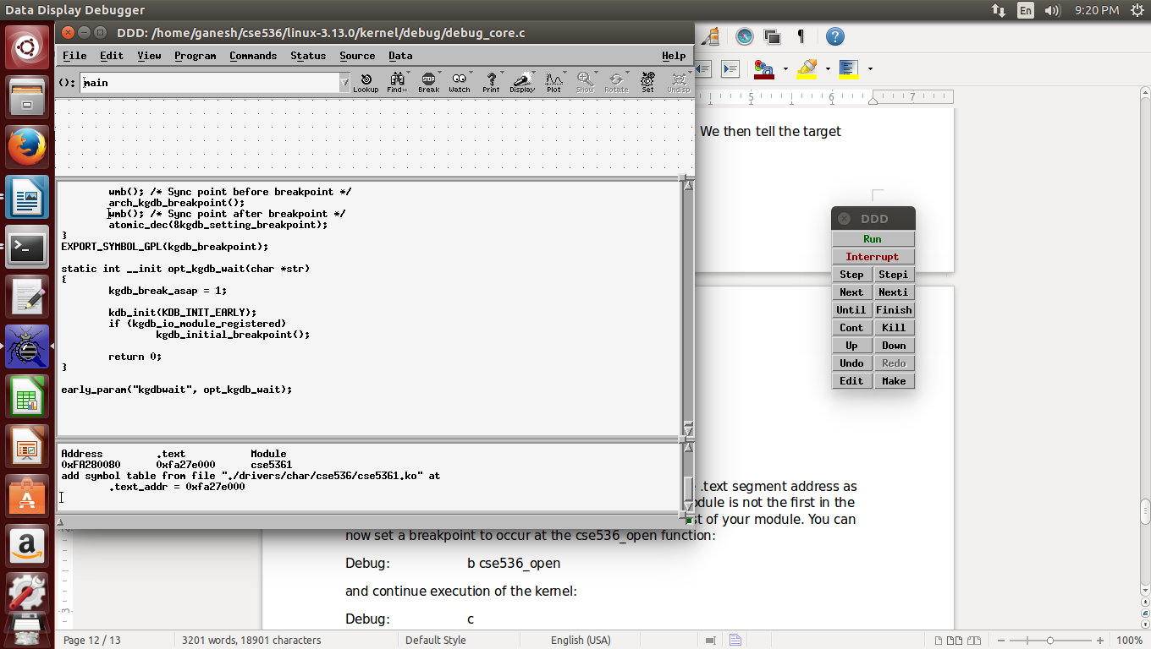

Figure : lsmod 1

The lsmod macro will locate the nth module and use the .text segment address as the basis for loading the cse5361.ko symbols. If your module is not the first in the list of modules change the 1 to the nth position in the list of your module. You can now set a breakpoint to occur at the cse536_open function:

Debug: b cse536_open

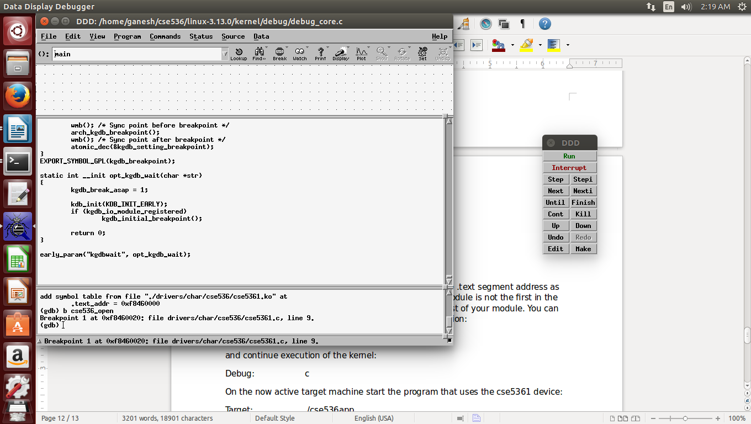

Figure : Insert breakpoint at cse536_open

and continue execution of the kernel:

Debug: c

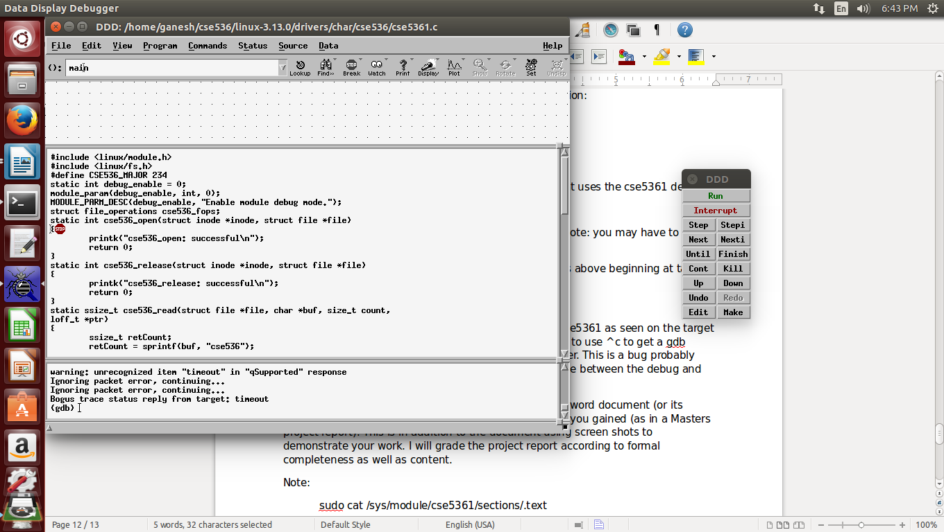

On the now active target machine start the program that uses the cse5361 device:

Target: ./cse536app

You should have a break at the cse536_open function. Note: you may have to enter ^c at this point on the debug VM to get a gdb prompt.

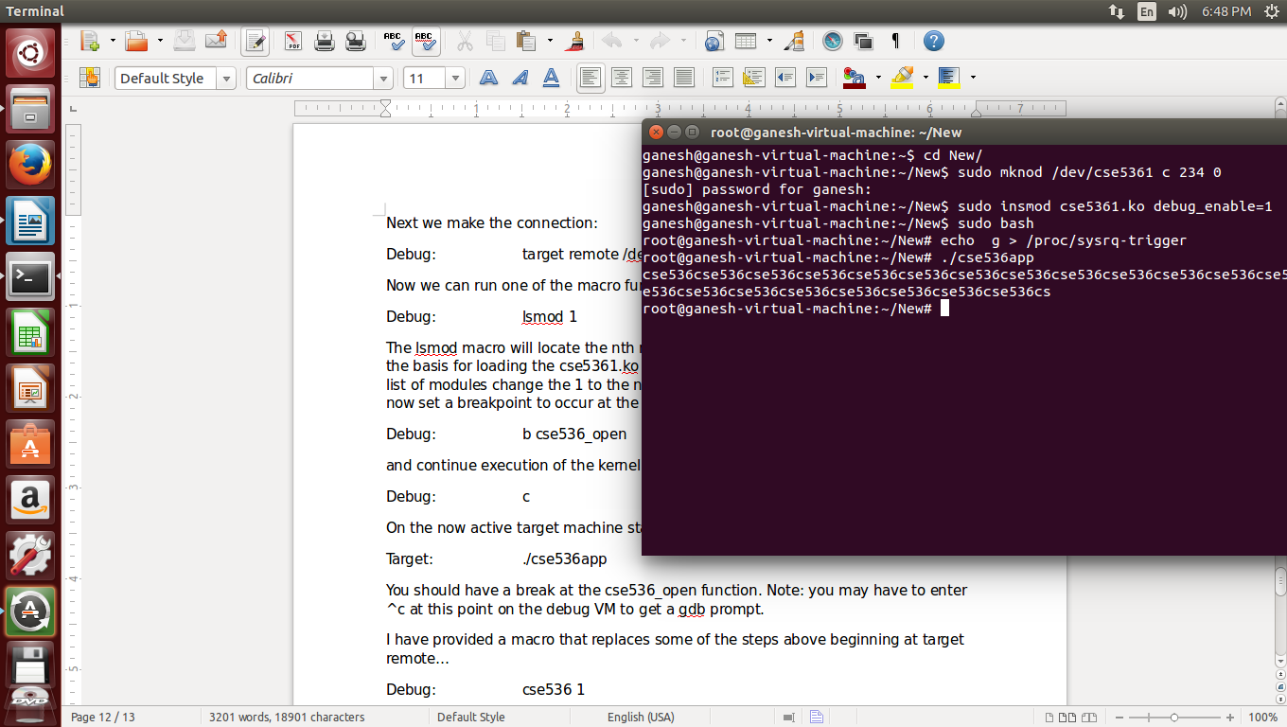

Figure : run cse536app in target VM

A macro that replaces some of the steps above beginning at target remote…

Debug: cse536 1

where the 1 is again the position in the module list of cse5361 as seen on the target VM using lsmod. Note again that you will probably need to use ^c to get a gdb prompt after starting cse536app on the remote computer. This is a bug probably caused by a change in the protocol used to communicate between the debug and target VMs in the 3.7 kernel.

To complete project 1 please create a formal report in a word document (or its equivalent) that describes project 1 and the experience you gained (as in a Masters project report). This is in addition to the document using screen shots to demonstrate your work. I will grade the project report according to formal completeness as well as content.

Note:

sudo cat /sys/module/cse5361/sections/.text

will also provide the address of the .text of the cse5361 module on the target machine if you want to load the symbols manually.

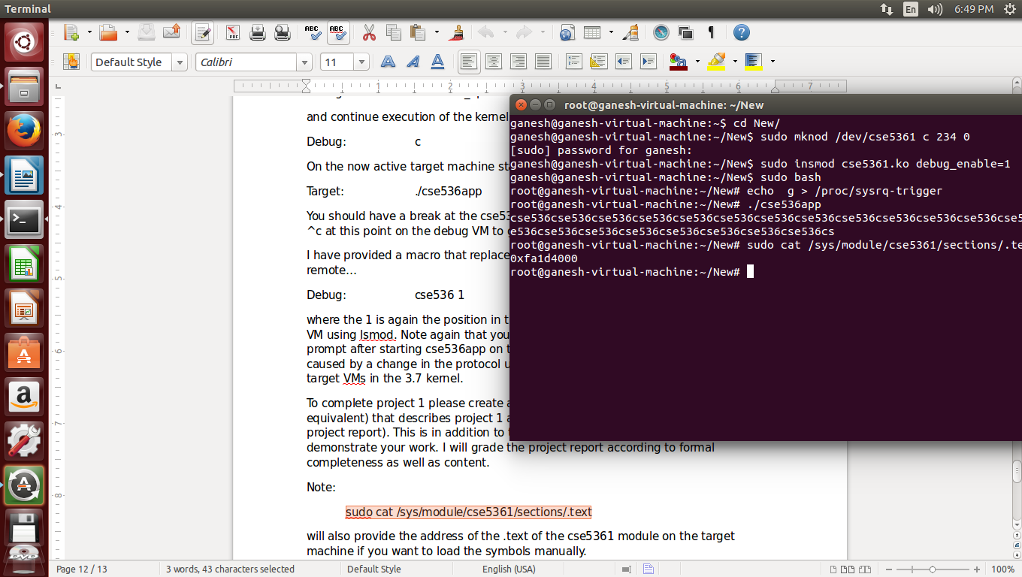

Figure : Address of cse5361 module

# Table of Figures

Figure 1: VMware Player 5

Figure 2: Ubuntu OS 6

Figure 3: Solution to flickered screen of Ubuntu 7

Figure 4: Create cse536 directory 9

Figure 5: Update Ubuntu 10

Figure 6: download ubuntu 11

Figure 7: menuconfig 12

Figure 8: clean build environment 13

Figure 9: version before loading new source 14

Figure 10: load new linux image 15

Figure 11: version after loading new linux image 15

Figure 12: compile and execute cse536app 16

Figure 13: menuconfig 17

Figure 14: rebuild kernel using new module 18

Figure 15: mknod cse5361 20

Figure 16: insert new module in kernel 21

Figure 17: install ddd 23

Figure 18: run program in ddd 24

Figure 19: Installation of gdbserver 28

Figure 20: Add User to dialout group 29

Figure 21: minicom : Set serial port 30

Figure 22: Edit grub 30

Figure 23: Start debugger with vmlinux 31

Figure 24: Create node cse5361 at target VM 34

Figure 25: connect with target through serial port 34

Figure 26: lsmod 1 35

Figure 27: Insert breakpoint at cse536_open 35

Figure 28: run cse536app in target VM 36

Figure 29: Address of cse5361 module 37

# References

1. <http://www.ubuntu.com/download/desktop/contribute/?version=14.04.1&architecture=i386>
2. <https://my.vmware.com/web/vmware/free#desktop_end_user_computing/vmware_player/6_0>
3. <http://askubuntu.com/questions/218296/problems-running-ubuntu-12-10-in-vmware-player-5>
4. <http://linux.die.net/man/1/minicom>
5. <http://www.gnu.org/software/ddd/>
6. <https://myasucourses.asu.edu/webapps/portal/frameset.jsp?tab_tab_group_id=_2_1&url=%2Fwebapps%2Fblackboard%2Fexecute%2Flauncher%3Ftype%3DCourse%26id%3D_290564_1>